**Apple Mail Signatures:**

**1. Create a signature in Apple Mail**

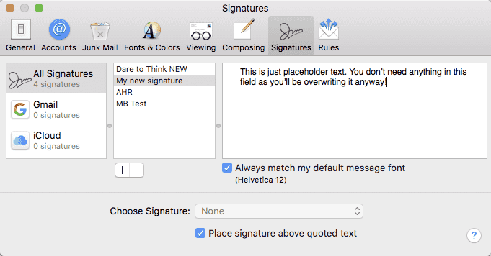

You need to do this so that your Mac creates a file, where you’ll then paste the HTML. Go to Apple Mail > Preferences… > Signatures and click the + button at the bottom of the second column (your signatures list).

Give your new signature a title and leave it at that (you don’t need to enter any text in the third (content) column, as you’ll be replacing this content later). Drag the signature (from the second column) on top of the email account you would like it to be associated with.

Quit Mail.

## 2. Open the Signatures folder

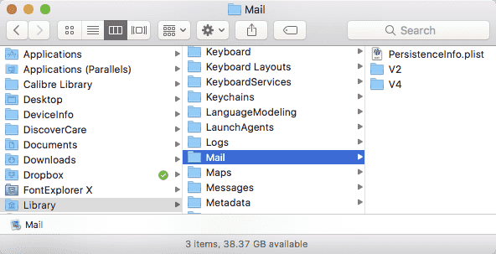

The quickest way of doing this is go to go your Finder and in the top menu bar click Go > Go to Folder… and enter “~/Library/Mail/” (excluding the quote marks). Now, you might see a few folders here. Select the latest “V” folder. For example if you see V2, V3 and V4 folders, open V4 (High Sierra is now V5, so open that one). Now open MailData > Signatures.

## 3. Paste the HTML Signature

In the Signatures folder (if you’ve got a lot of files in this folder, view the folder as a list and order by the Date Modified column) locate the newest file that ends .mailsignature and will have a load of letters and numbers as the file name. Right-Click or CTRL-Click on the signature and choose Open With > TextEdit.

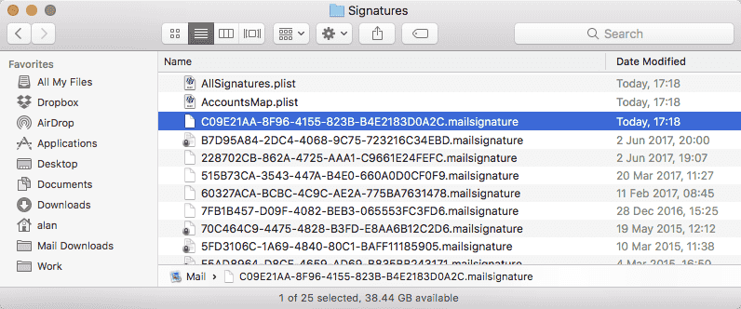

Delete all text starting from <body

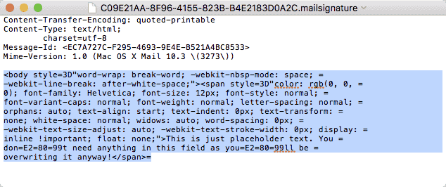

Open your new HTML Signature file (that your designer/developer provided) in TextEdit and copy the text (only copy from the start of, and including, <body> tag and ending at, and including the </body> tag and paste into position in the previous file you’ve just opened

Save, but do not close, the file.

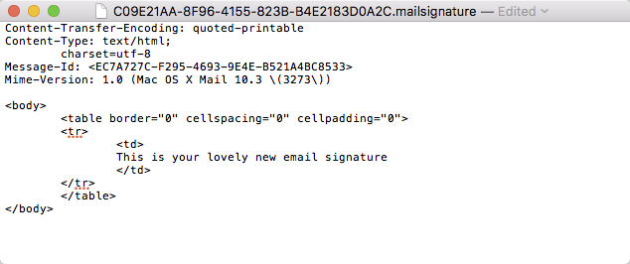

## 4. Lock the file

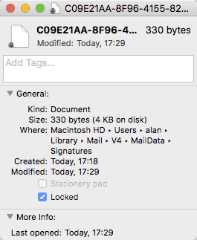

Go back to your Finder, highlight the .mailsignature file and select File > Get Info and check the “Locked” checkbox.

## 5. Look at your lovely new signature!

Open Apple Mail and create a new email (File > New Message). Select your new email signature from the Signatures dropdown and there you have it!

## Anything else…

**Default Signature.** If you would like this to be your default signature go to File > Preferences… > Signatures. Select your email account in the first column from the Choose Signature dropdown, select your new signature.

**My new signature doesn’t show**. Make sure you checked the Locked checkbox in Step 5, otherwise Apple will overwrite that file.